CHAPTER 2-8

regular grammars

- So far, we have considered 2 equivalent ways to describe exactly the class of regular languages: FSMs and regular expressions. We now introduce a third: regular grammars.

Definition of a regular grammar

- A regular grammar G is a quadruple (V, Σ, R, S), where:
  - V is the grammar alphabet, which contains 3 kinds of symbols:
    - nonterminals (or variables) are symbols that are used in the grammar G but do not appear in the language generated by the grammar, L(G)
    - terminals are symbols that can appear in L(G)
    - ε
  - Σ is the set of terminals and it is a subset of V
  - R is a finite set of rules (or productions) of the form X→Y where
  - X is a single nonterminal
  - Y is:
  - ε, or
  - a single terminal, or
  - a single terminal followed by a single nonterminal.
  - In other words, all productions are of the form:
A→ε
A→x
A→xB
where A, B are nonterminals, and x∈Σ.
  - Not legal: S → aSa and aSa → T
  - S is the start symbol and it is a nonterminal
- A string w is in L(G) iff we can start with S, apply a sequence of rules in R, and arrive at w.
- If w∈L(G), then the sequence S⇒w₁⇒ w₂⇒ …⇒ w_{n}⇒w is called a derivation of the word w. The symbol ⇒ means "can develop into using 1 rule". The strings S, w₁, w₂, …, w_{n} which contain variables and terminals are called sentential forms of the derivation.
- At any point of a derivation, a sentential form contains exactly 1 nonterminal
- If w₁⇒ w₂⇒ …⇒ w_{n}, we write w₁⇒*w_{n}. The ⇒* means "can develop into using 0 or more rules".
- The language generated by G, L(G), is {w∈Σ*|S⇒*w}, i.e., the set of all strings w in Σ* such that it is possible to start with S, apply some finite set of rules in R, and derive w.

Ex2-8-1 L = {w ∈ {a, b}* : |w| is even}.
L can be generated by the regular expression: ((aa)∪(ab)∪(ba)∪(bb))*
The following DFSM accepts L:
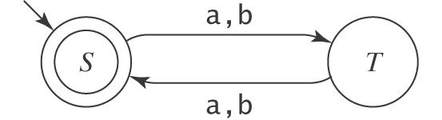
The following grammar G also defines L:
S → ε
S → aT
S → bT
T → aS
T → bS
In G, the job of S is to generate an even length string, while the job of T is to generate an odd length string. We can rewrite the grammar using a shorthand:
S → ε | aT | bT
T → aS | bS
The string abab is in L because:
S⇒aT⇒ abS⇒abaT⇒ ababS⇒ abab

Theorem Any regular language can be generated by a regular grammar
Proof Constructive algorithm (DfsmToGrammar).
Any regular language can be accepted by a DFSM. Given any DFSM, we construct the corresponding regular grammar as follows:
- The nonterminals in the regular grammar are the names of the states in the DFSM with the start symbol renamed S.
- For every edge:
X
Y
a
we create the production X→aY.
- For every loop:
a
X

we create the production X→aX.
- For every final state X, create the production X→ε.
We now show that this RG generates exactly the language accepted by the original DFSM.
Case 1. Let w be a string accepted by the DFSM. When we trace the path of w on the DFSM, every edge we follow has a corresponding production. Thus, we can simultaneously trace the derivation of the w using the regular grammar. When we land on a final state Y, we will use the Y→ε production to finish the derivation. Thus, every word accepted by the DFSM can be generated from the regular grammar.
Case 2. Let w be a string generated by the regular grammar. When we trace the derivation of w, every step has a corresponding edge in the DFSM. Thus, we can simultaneously trace the path of the w on the DFSM. Thus, every word generated by the regular grammar is accepted by the DFSM.

Ex2-8-2 Given the following DFSM, which accepts L((a∪b)*aa(a∪b)*)
b a a a, b
-S
+F
M

b
Construct a regular grammar for L following algorithm DfsmToGrammar.
- S→aM | bS
- M→aF | bS
- F→aF | bF | ε
The word babaa is accepted by this DFSM through this computation:
(S, babaa)|-(S, abaa) |- (M, baa) |- (S, aa) |- (M, a) |- (F, ε)
This corresponds to the derivation:
S⇒bS⇒ baM⇒babS⇒ babaM ⇒ babaaF ⇒ babaa

Theorem Any regular grammar generates a regular language
Proof Constructive algorithm (GrammarToNDfsm).
Given the following regular grammar (N_{i} is a nonterminal, x_{i} is a terminal):
S→x₁N₂
N₂→x₂N₃
N₃→x₃N₄
…
We construct a NDFSM as follows.
- Draw a state for each N, 1 for S, and 1 labeled +. The state for S is labeled -.

N₂
N₃
-S
+
……
- For each N_{i}→x_{j}N_{k}, draw an edge from N_{i} to N_{k} with label x_{j}. If N_{i}=N_{k}, the path is a loop.
- For each N_{i}→x_{j}, draw an edge from N_{i} to + with label x_{j}
- For each N_{i}→ε, make the state N_{i} a final state.
We can show that this NDFSM accepts exactly the language generated by the original regular grammar.
Case 1. Let w be a string accepted by the NDFSM. When we trace the path of w on the NDFSM, every edge we follow has a corresponding production. Thus, we can simultaneously trace the derivation of the w using the RG. Thus, every word accepted by the NDFSM can be generated from the RG.
Case 2. Let w be a string generated by the regular grammar. When we trace the derivation of w, every step has a corresponding edge in the NDFSM. Thus, we can simultaneously trace the path of the w on the NDFSM. Thus, every word generated by the regular grammar is accepted by the NDFSM.

Ex2-8-3 Given this regular grammar G:
S → aS S → bS S → aB
B → aC
C → aD
D → a
Construct a NDFSM for L(G) following algorithm GrammarToNDfsm.
Using algorithm GrammarToNDfsm, the following NDFSM that accepts the same language:
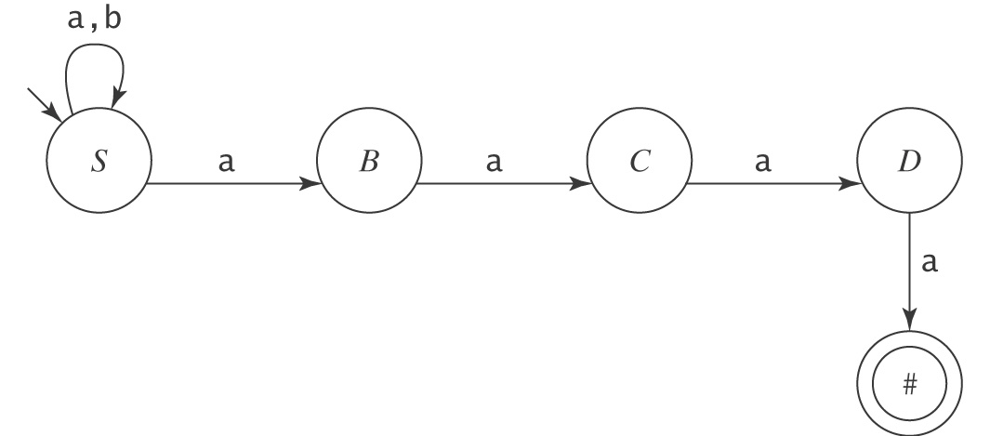
G accepts L = {w ∈ {a, b}* : w ends with the pattern aaaa}.
S – Not last 4 letters yet
B – Just generated the last but 4th a
C – Just generated the last but 3rd a
D – Just generated the last but 2nd a
# – Just generated the last a

Ex2-8-4 Given this regular grammar G:
S → ε A → bA C → aC
S → aB A → cA C → bC
S → aC A → ε C → ε
S → bA B → aB
S → bC B → cB
S → cA B → ε
S → cB
Construct a NDFSM for L(G) following algorithm GrammarToNDfsm.
Using algorithm GrammarToNDfsm, the following NDFSM that accepts the same language:
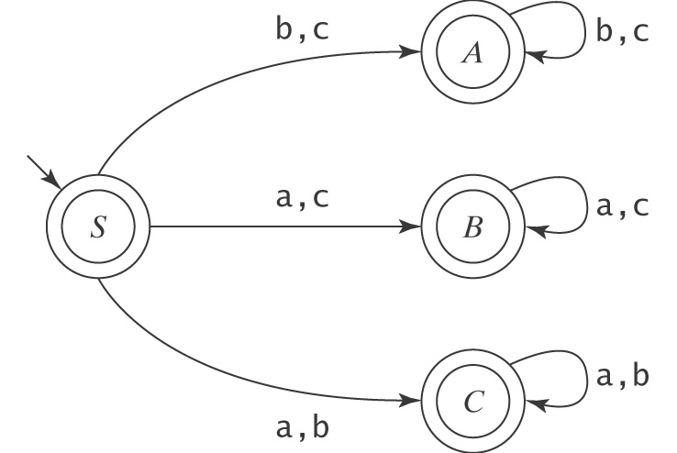
G accepts L = {w∈{a, b, c}*: one character from the alphabet missing in w}.
S – Every character missing
A – a missing
B – b missing
C – c missing

Theorem The class of languages that can be defined with regular grammars is exactly the regular languages.
Proof Proved by the combination of the above 2 theorems.

Ex2-8-5 Let L={wε{a,b}*:w contains an odd number of a's and w ends in a}. Write a regular grammar G that defines L.
S→bS //After this, the number of a's is even
S→aT //After this, the number of a's is odd and the derived string ends in a
T→ε //Since the number of a's is odd and the derived string ends in a, can quit
T→aS //After this, the number of a's is even
T→bX //After this, the number of a's is odd and the derived string does not end in a
X→aS //After this, the number of a's is even
X→bX //After this, the number of a's is odd and the derived string does not end in a
To see how this grammar works, we can watch it generate the string baababaa:
S⇒bS //even umber of a's
⇒baT //odd umber of a's and ends in a, can quit
⇒baaS //even umber of a's
⇒baabS //even umber of a's
⇒baabaT // odd umber of a's and ends in a, can quit
⇒baababX // odd umber of a's and does not end in a
⇒baababaS // even umber of a's
⇒baababaaT // odd umber of a's and ends in a, can quit
⇒baababaa

- So, regular grammars define exactly the regular languages. But regular grammars are not often used in practice. The reason is not that they cannot be. It is simply FSM and regular expressions are easier to work with.
- In practice, to design a RG for L, it usually is easier to design a DFSM for L, then convert.
a
-S
+T

a
b b
X
a b

Homework problems

- Consider the following regular grammar G:
S → aT
T → bT
T → a
T → aW
W → ε
W → aT
Use GrammarToNDfsm to generate an NDFSM M that accepts L(G).

- Construct a regular grammar from the following DFSM which defines {awa:w∈{a,b}*}, using algorithm DfsmToGrammar.
b a
a a
-S
A
+C

b
b
B

a,b

- Construct a regular grammar which defines L={wε{a,b}*:w starts with an a and ends with a b}.

